



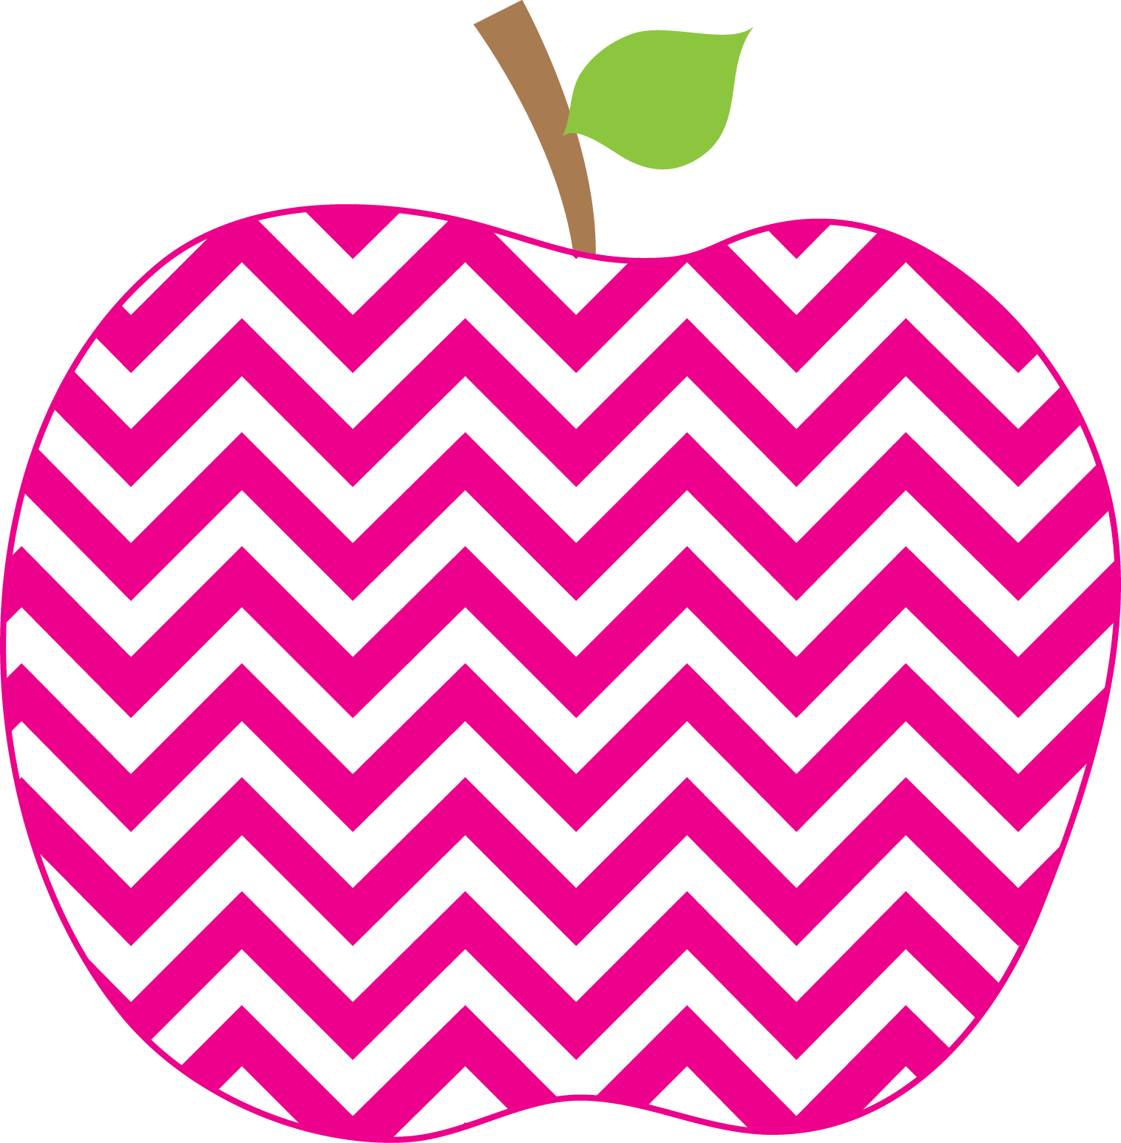

Weekly News

MRS. HOLLOWAY’S CLASS Sept 12th SSept.12t19Sep16th

Literacy- Each week I will inform you of the Literacy focus for all of the grade one classes.

We are currently reviewing the Kindergarten sight work list. Last week the words were an, all, a, all, and. Words for this week are: in, is, that, it, was. The objective is that children can recognize these words in a “snap”.
Reviewing the name of, sound of and formation of s and t. Last week we did a and s.
The word family we will review is “at” family.. bat, sat, hat, rat etc
The Reading Strategy for the week is EAGLE EYE.

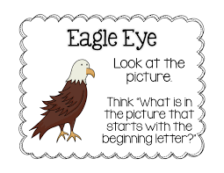
Writing- We will start talking about the Write Trait,”Ideas” and work on, “I can think of a topic I know about and care about”. We will work on writing personal narratives.

Math- We have started a unit on Patterns. The grade one focus is on Repeating Patterns, and being able create, extend and copy a pattern.

YYWorld; Positive Interactions, Respect, getting along with our friends.
Learning Focus for the Week
Thank you to all of the parents who attended Meet The Teacher Night to hear about the upcoming year! Watch for Hot Lunch and Milk forms coming home soon.
This week we will have a performance called “Blues In the School”.

The first week of grade one went quite well and the students are adjusting to being back to school! I am hoping that this week will be a bit cooler.

If you have not sent in your $45 school fees please do so. There were several information sheets sent home last week that some families still need to return.
Homework
Your child is bringing home two books for Home Reading. Research has shown that rereading a text will improve both comprehension and fluency. Return on Thursday please. Please find in the folder, a Pattern Homework Math Sheet that you may choose to do with your child. These are not returned to school.
Information

